**WRITE UP**

**PROJECT: Displaying User Feedback**

**Project Description:**

* Create a Spring Boot project that will capture user feedback using a REST endpoint.
* The REST resource will take in parameters using HTTP POST.
* The feedback data will be then added to a database table.

**Application Flow:**

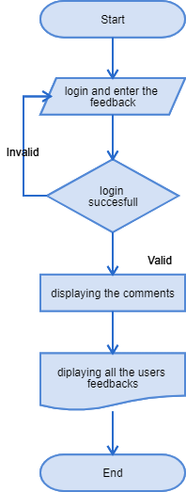

**Core concepts used in project:**

● Eclipse as the IDE  
● Apache Tomcat as the web server  
● Spring Boot with Hibernate

**Conclusion** of the project is designed for Displaying User Feedback.